Tasks on SQL:

1. Show all info about the employee with ID 8.

SELECT \*

FROM Employees

WHERE EmployeeID = 8

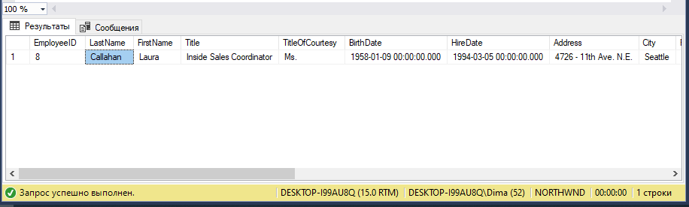

1. Show the list of first and last names of the employees from London.

SELECT FirstName,LastName

FROM Employees

WHERE City = 'London'

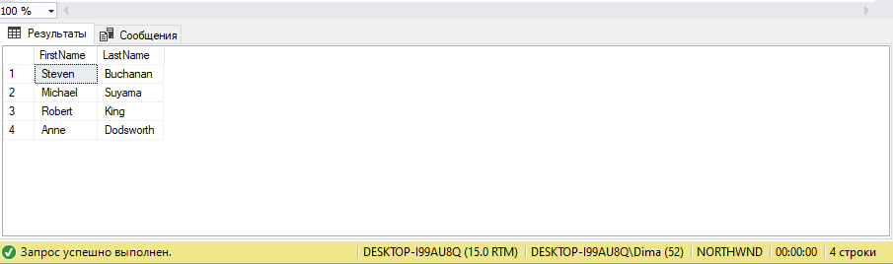

1. Show the list of first and last names of the employees whose first name begins with letter A.

SELECT FirstName,LastName

FROM Employees

WHERE FirstName LIKE 'A%'

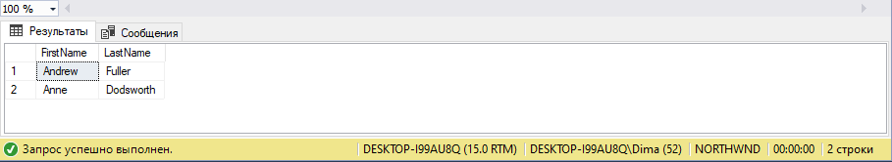

1. Show the list of first, last names and ages of the employees whose age is greater than 55. The result should be sorted by last name.

SELECT FirstName,LastName,DATEDIFF(YEAR,BirthDate,GETDATE()) AS Age

FROM Employees

WHERE DATEDIFF(YEAR,BirthDate,GETDATE()) > 55

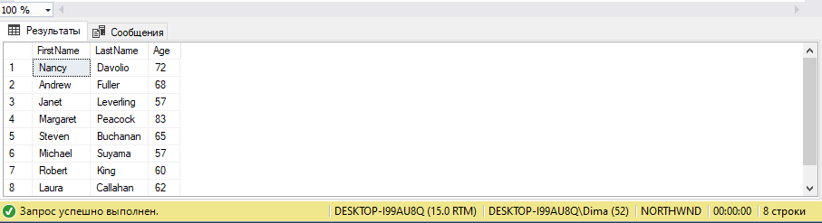

1. Calculate the count of employees from London.

SELECT COUNT(EmployeeID) as FromLondon

FROM Employees

WHERE City = 'London'

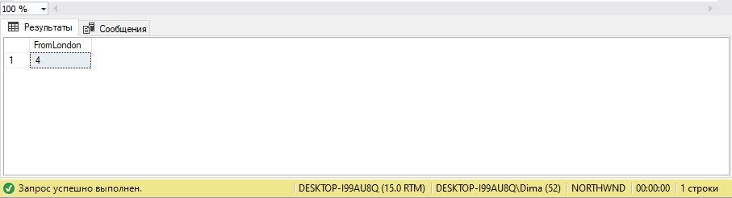

1. Calculate the greatest, the smallest and the average age among the employees from London.

SELECT MAX(DATEDIFF(YEAR,BirthDate,GETDATE())) as MaxAge

,MIN(DATEDIFF(YEAR,BirthDate,GETDATE())) as MinAge

,AVG(DATEDIFF(YEAR,BirthDate,GETDATE())) as AvgAge

FROM Employees

WHERE City = 'London'

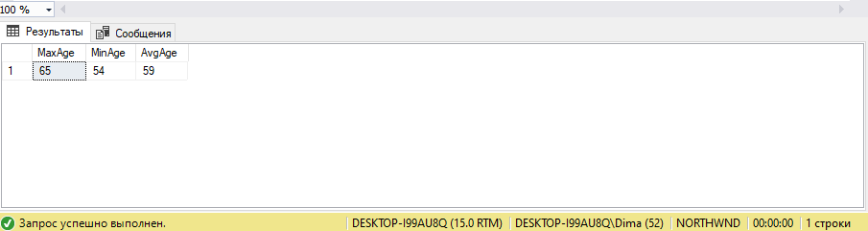

1. Calculate the greatest, the smallest and the average age of the employees for each city.

SELECT City

,MAX(DATEDIFF(YEAR,BirthDate,GETDATE())) as MaxAge

,MIN(DATEDIFF(YEAR,BirthDate,GETDATE())) as MinAge

,AVG(DATEDIFF(YEAR,BirthDate,GETDATE())) as AvgAge

FROM Employees

GROUP BY City

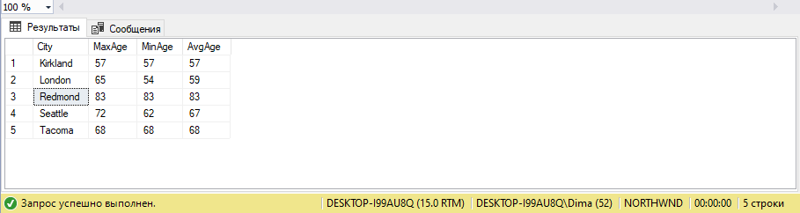

8. Show the list of cities in which the average age of employees is greater than 60 (the average

age is also to be shown)

SELECT City

,AVG(DATEDIFF(YEAR,BirthDate,GETDATE())) AS AvgAge

FROM Employees

GROUP BY City

HAVING AVG(DATEDIFF(YEAR,BirthDate,GETDATE())) > 60

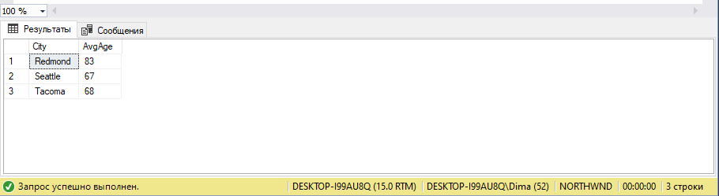

1. Show the first and last name(s) of the eldest employee(s). Use a subquery.

SELECT FirstName,LastName

FROM Employees

WHERE BirthDate = (SELECT MIN(BirthDate)

FROM Employees)

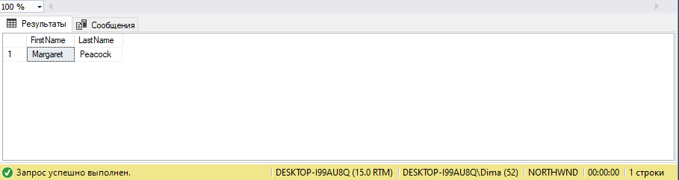

1. Show first, last names and ages of 3 eldest employees.

SELECT FirstName

,LastName

,DATEDIFF(YEAR,BirthDate,GETDATE()) as Age

FROM Employees

WHERE BirthDate IN (SELECT TOP (3) BirthDate

FROM Employees

ORDER BY BirthDate)

ORDER BY Age DESC

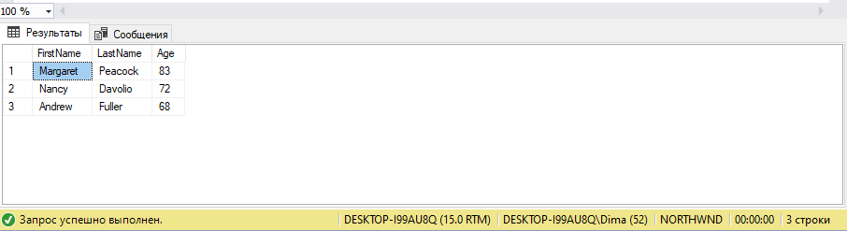

1. Show the list of all cities where the employees are from.

SELECT DISTINCT City

FROM Employees

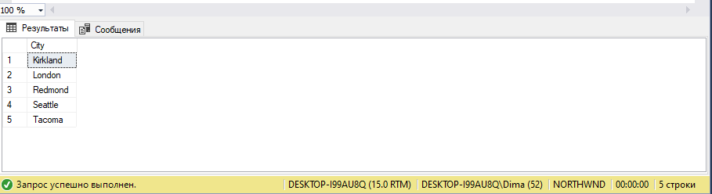

1. Show first, last names and dates of birth of the employees who celebrate their birthdays this month.

SELECT FirstName,LastName,BirthDate

FROM Employees

WHERE MONTH(GETDATE()) = MONTH(BirthDate)

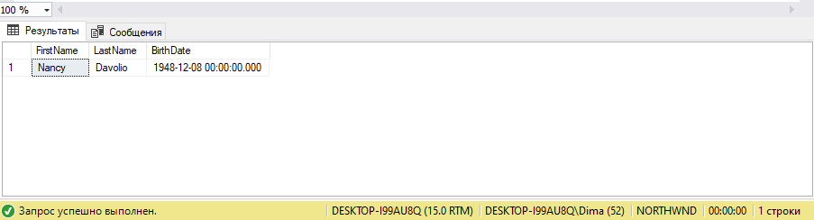

1. Show first and last names of the employees who used to serve orders shipped to Madrid.

SELECT FirstName,LastName

FROM Employees e,Orders o

WHERE o.EmployeeID = e.EmployeeID AND o.ShipCity = 'Madrid'

GROUP BY FirstName,LastName

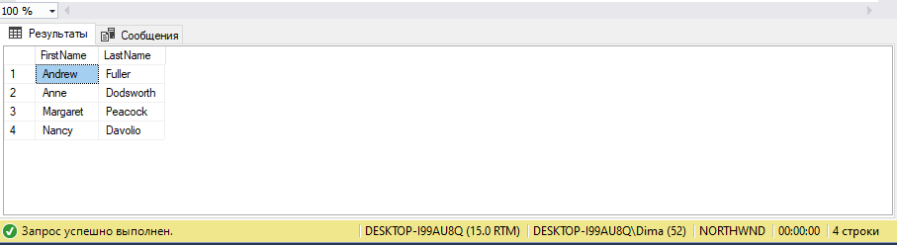

14. Show first and last names of the employees as well as the count of orders each of them have

received during the year 1997 (use left join).

SELECT FirstName,LastName,COUNT(e.EmployeeID) as OrderCount

FROM Employees e

LEFT JOIN Orders o ON e.EmployeeID = o.EmployeeID

WHERE YEAR(o.OrderDate) = 1997

GROUP BY FirstName,LastName

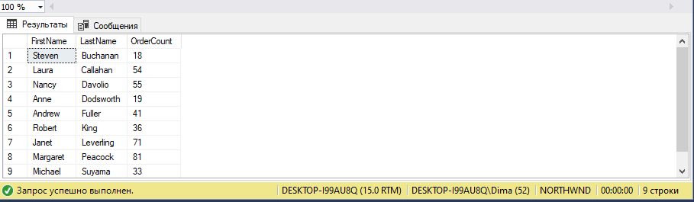

15. Show first and last names of the employees as well as the count of orders each of them have

received during the year 1997 (use a subquery).

SELECT e.FirstName,e.LastName,COUNT(o.OrderID)

FROM Employees e,Orders o

WHERE e.EmployeeID = o.EmployeeID AND o.OrderID IN (

SELECT o.OrderID

WHERE YEAR(o.OrderDate) = 1997)

GROUP BY e.FirstName,e.LastName

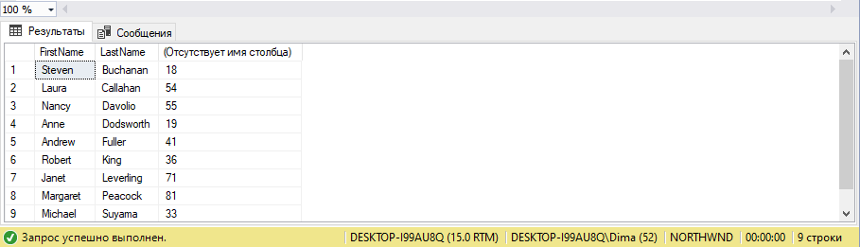

16. Show first and last names of the employees as well as the count of their orders shipped after required date during the year 1997 (use left join).

SELECT e.FirstName,e.LastName,COUNT(e.EmployeeID) AS OrderCount

FROM Employees e

LEFT JOIN Orders o ON e.EmployeeID = o.EmployeeID

WHERE YEAR(o.OrderDate) = 1997 AND O.OrderDate > O.RequiredDate

GROUP BY e.FirstName,e.LastName

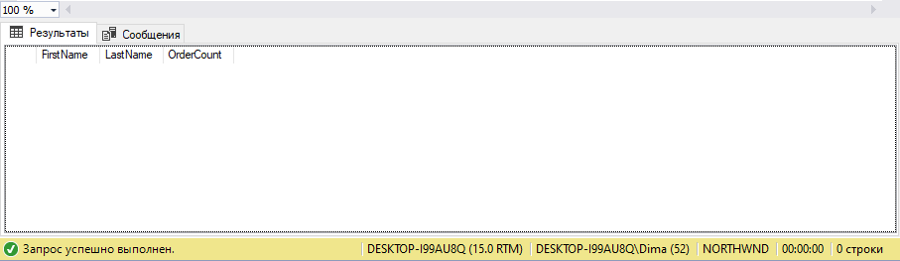

17. Show the count of orders made by each customer from France.

SELECT COUNT(c.CustomerID) as OrderCount

FROM Customers c,Orders o

WHERE c.CustomerID = o.CustomerID AND c.Country = 'France'

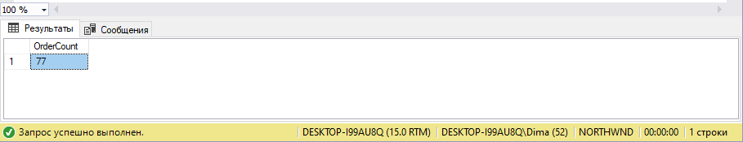

18. Show the list of french customers’ names who have made more than one order (use grouping).

SELECT c.ContactName

FROM Customers c

LEFT JOIN Orders o ON c.CustomerID = o.CustomerID

WHERE c.Country = 'France'

GROUP BY c.ContactName

HAVING COUNT(o.OrderID) > 1

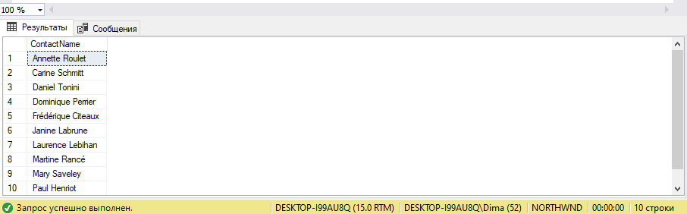

19. Show the list of french customers’ names who have made more than one order (use a

subquery).

SELECT c.ContactName

FROM Customers c

WHERE c.Country = 'France' AND 1 < (

SELECT COUNT(o.OrderID)

FROM Orders o

WHERE c.CustomerID = o.CustomerID)

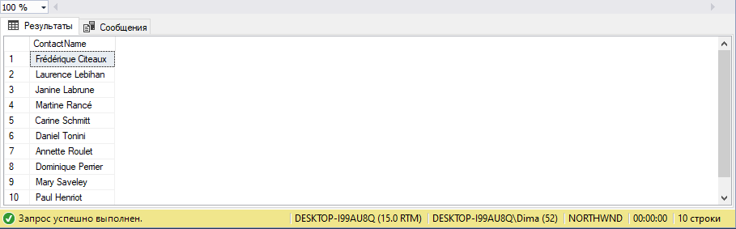

20. Show the list of customers’ names who used to order the ‘Tofu’ product (use a subquery).

SELECT c.ContactName

FROM Customers c

WHERE c.CustomerID IN (

SELECT o.CustomerID

FROM Orders o,[Order Details] od,Products p

WHERE o.OrderID = od.OrderID AND od.ProductID = p.ProductID AND p.ProductName = 'Tofu')

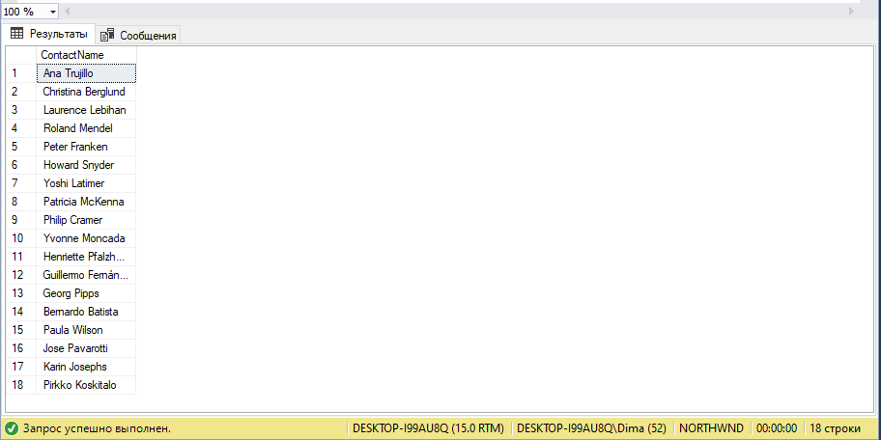

21. \*Show the list of customers’ names who used to order the ‘Tofu’ product, along with the total

amount of the product they have ordered and with the total sum for ordered product

calculated.

SELECT c.ContactName, COUNT(c.CustomerID) as OrderTofuCount, SUM(p.UnitPrice) as Price

FROM Customers c,Orders o,[Order Details] od,Products p

WHERE c.CustomerID = o.CustomerID AND o.OrderID = od.OrderID AND od.ProductID = p.ProductID AND p.ProductName = 'Tofu'

GROUP BY c.ContactName

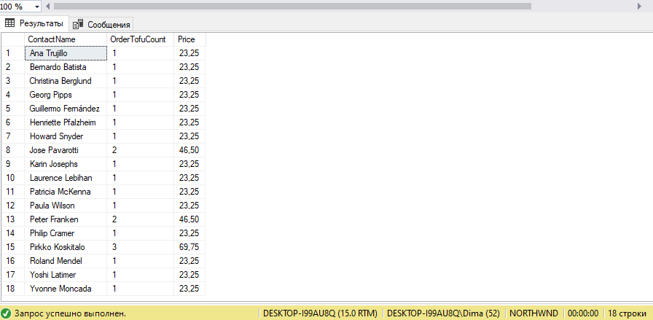

22. \*Show the list of french customers’ names who used to order non-french products (use left

join).

23. \*Show the list of french customers’ names who used to order non-french products (use a

subquery).

SELECT c.ContactName

FROM Customers c

WHERE c.Country = 'France' AND c.CustomerID IN (SELECT c.CustomerID

FROM Customers c,Orders o,[Order Details] od,Products p,Suppliers s

WHERE c.CustomerID = o.CustomerID AND o.OrderID = od.OrderID AND od.ProductID = p.ProductID

AND p.SupplierID = s.SupplierID AND s.Country <> 'France')

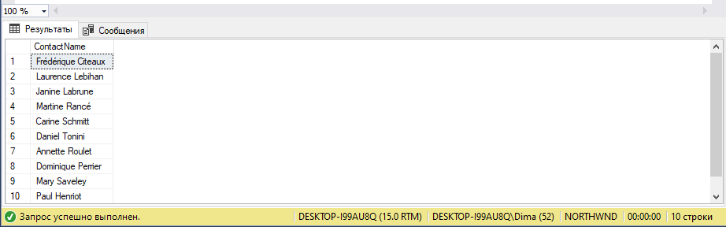

24. \*Show the list of french customers’ names who used to order french products.

SELECT c.ContactName

FROM Customers c

WHERE c.Country = 'France' AND c.CustomerID IN (SELECT c.CustomerID

FROM Customers c,Orders o,[Order Details] od,Products p,Suppliers s

WHERE c.CustomerID = o.CustomerID AND o.OrderID = od.OrderID AND od.ProductID = p.ProductID

AND p.SupplierID = s.SupplierID AND s.Country = 'France')

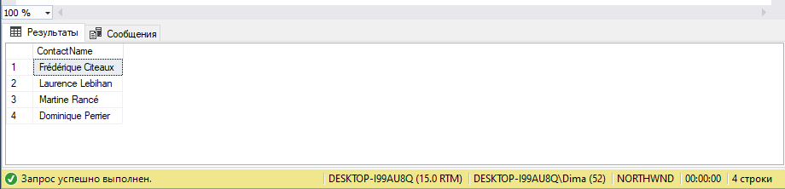

25. \*Show the total ordering sum calculated for each country of customer.

SELECT c.Country,SUM(p.UnitPrice) as Costs

FROM Customers c,Orders o,[Order Details] od,Products p

WHERE c.CustomerID = o.CustomerID AND o.OrderID = od.OrderID AND od.ProductID = p.ProductID

GROUP BY c.Country

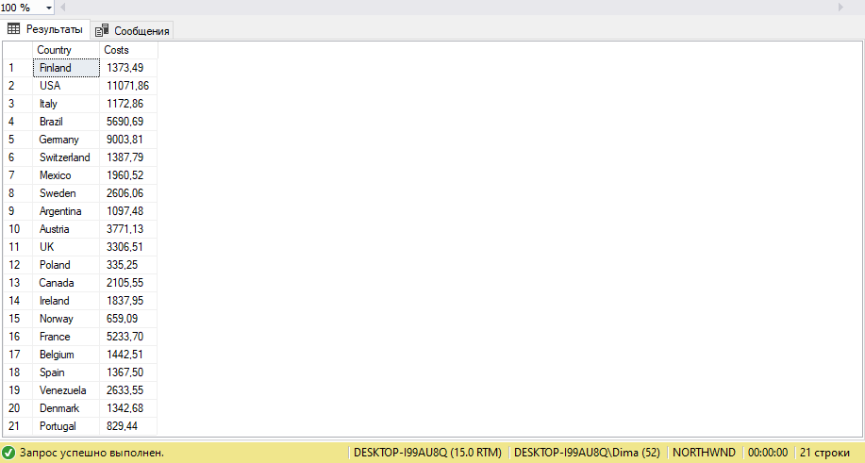

27. \*Show the list of product categories along with total ordering sums calculated for the orders

made for the products of each category, during the year 1997.

SELECT CategoryName, SUM(Products.UnitPrice) As TotalSum

FROM Categories, Products, [Order Details], Orders

WHERE Products.CategoryID = Categories.CategoryID AND [Order Details].ProductID = Products.ProductID AND YEAR(Orders.OrderDate) = 1997 AND Orders.OrderId = [Order Details].OrderID

GROUP BY CategoryName

